WINDOW FUNCTIONS

- create database new;
- use new;

- select new_id,new_cat,Sum(new_id) Over (partition by new_cat) As "Total" from newid;
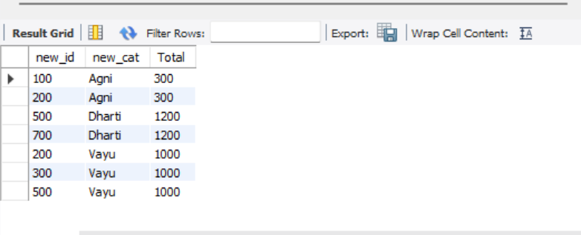

- select new_id,new_cat,Sum(new_id) Over (partition by new_cat order by new_id) As "Total" from newid;
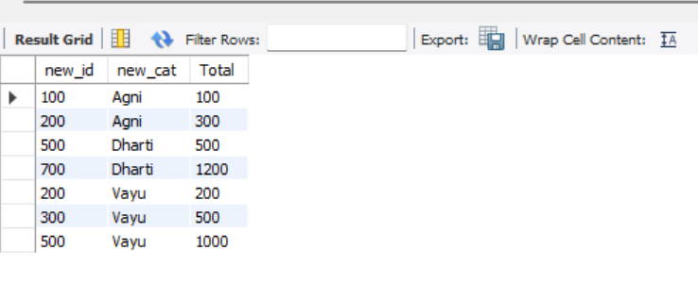

- select new_id,new_cat,
sum(new_id) OVER (PARTITION BY new_cat ORDER BY new_id) AS "TOTAL",
AVG (new_id) OVER (PARTITION BY new_cat ORDER BY new_id) AS "Average" ,
count(new_id) OVER (PARTITION BY new_cat ORDER BY new_id) AS "COUNT",
max(new_id) OVER (PARTITION BY new_cat ORDER BY new_id) AS "MAX",
min(new_id) OVER (PARTITION BY new_cat ORDER BY new_id) AS "MIN"
from newid;
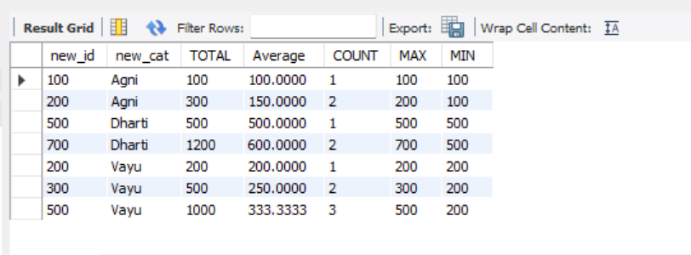

- SELECT new_id,new_cat,
sum(new_id)over(order by new_id rows between unbounded preceding and unbounded following)
as "Total" from newid;
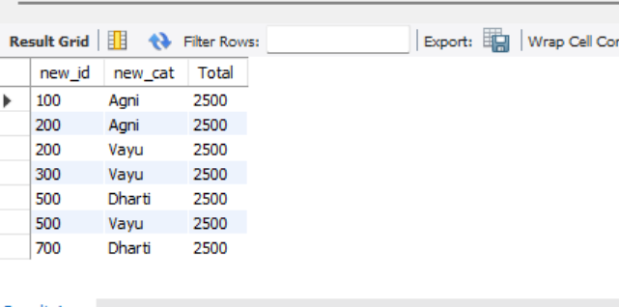

- select new_id, row_number() over(order by new_id)
as "Row number",
rank() over(order by new_id ) as "Rank",
dense_rank() over(order by new_id) as "Dense_rank",
percent_rank() over(order by new_id) as "Percent_rank"
from newid;
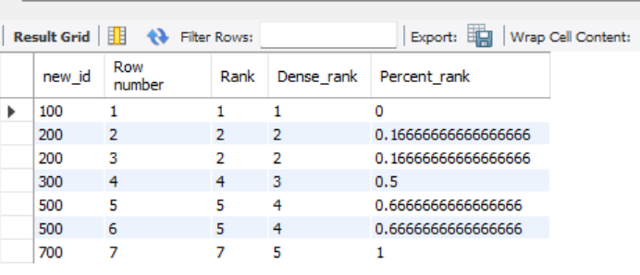

- Calculate the running total of sales amount
SELECT salesid,saledate,amount,SUM(amount) OVER (ORDER BY saledate) AS "RunningTotalSales"
FROM customer;
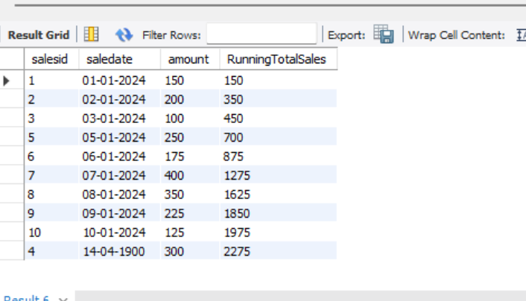

- Rank the sales by amount for each customer.
SELECT salesid, saledate,customerid,amount,
rank() over(partition by customerid order by amount DESc)
AS "Rank BY Amount"
FROM customer;
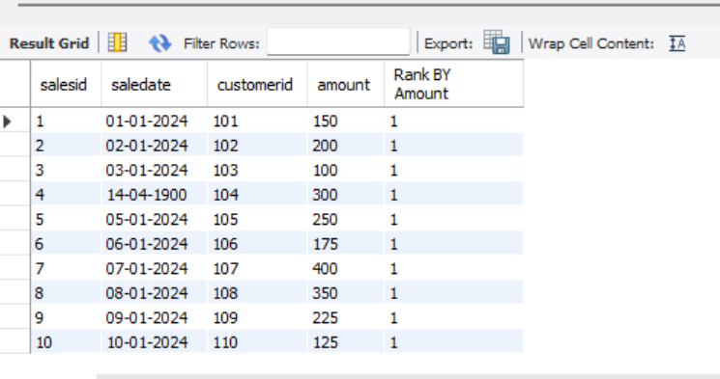

- Calculate avg sales amount over the last 3 sales.
Select
salesid,saledate,
amount,
avg(amount) over(order by saledate Rows between 2 preceding and current row)
As "AvgLast3sales"
FROM customer;
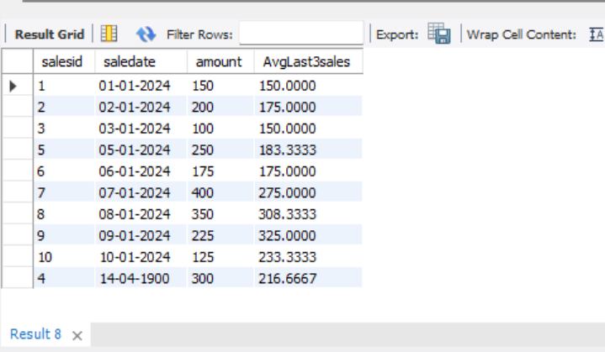

- Calculate the cumulative distribution sales amount.
SELECT
salesid,
saledate,
amount,
CUME_DIST() OVER (ORDER BY Amount) AS CumulativeDistribution
FROM customer;
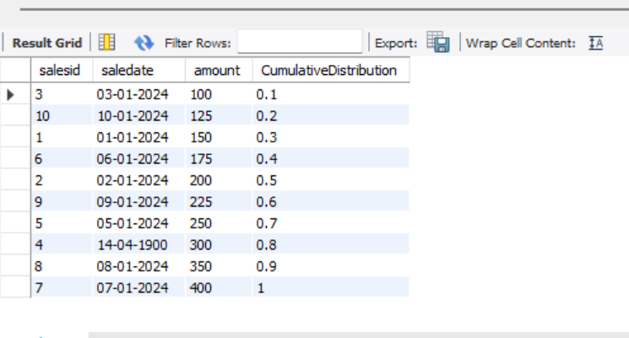

- Calculate the lead sales amount for the next sale.
SELECT
salesid,
saledate,
amount,
LEAD(amount,1) OVER (ORDER BY saledate) AS SALESAMOUNT
FROM customer;
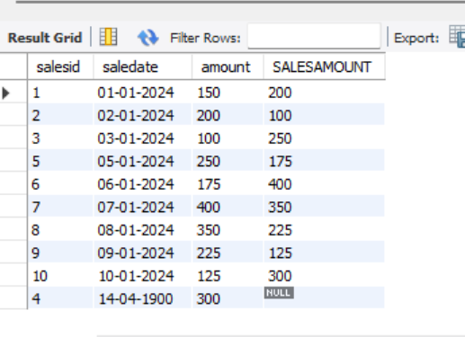

SELECT
salesid,
saledate,
amount,
Lag(amount,1) OVER (ORDER BY saledate) AS SALESAMOUNT
FROM customer;
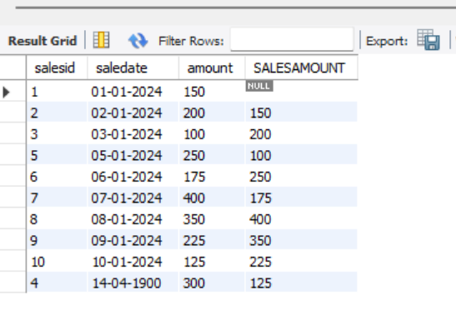

- Find the first sale amount fir each customer.
select salesid,
saledate,
customerid,
amount,
first_value(amount) over (partition by customerid order by saledate)
as "FirstSaleAmount"
from customer;
